**ONE-CARD**

**Game concept**

* One card – The objective is for a player to empty their own hand while preventing other players from emptying theirs

**Game play idea**

* Create a game similar to Uno which operates on the same basic mechanics of removing and drawing cards
* Players aim to remove their cards from their own deck as soon as possible. If any of the player has no more cards, the game is over with that player as the winner
* 3 players (user, user2, user3) – turn based function
* Each player is dealt 7 cards
* You can play 1 card that has the same colour/number per turn (unless special cards are used)
* One card is laid face up in the middle forming the discard pile
* The remaining cards will make a stock pile
* Draw a card from the deck if you are unable to, or do not want to play anything
* Each turn ends when a card is played/drawn

**MVP**

The game will need to have the following features at the minimum:

* A gameboard
* Players
* Clickable cards to play and draw
* Will be able to move on to next player when a card is played

Bonus

* Include animation
* Start/continue game and instructions
* Make it multiplayer
* Option to start new game
* Load screen that enables player to play new round
* Background sound/effects
* If no card was placed after 10s, a random card will be taken from the pile
* Design
* Features

**Wireframe**

* Landing page

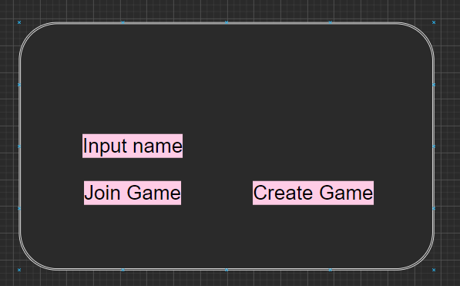

* Instruction pop-up

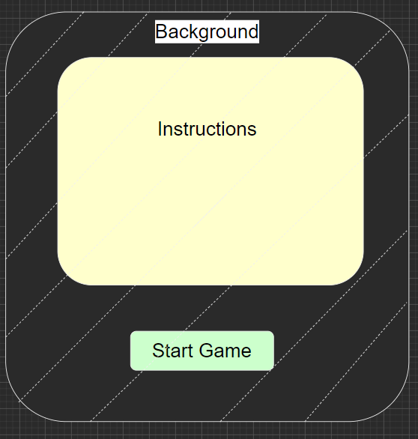

* Game page is loaded once “Start Game” is pressed. Players will be able to distinguish when is their turn by colour

The restart button is at the top-right of the page

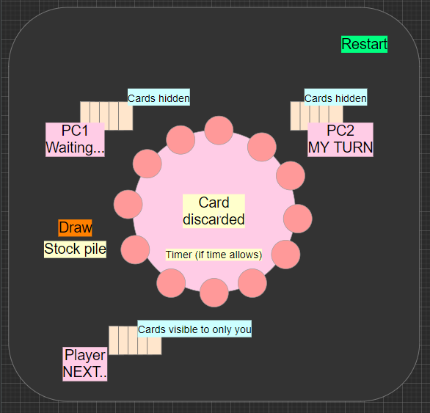

* Pop-up appears to indicate who has won and if they would like a rematch. Restarts the game and the players are dealt with 7 random cards again

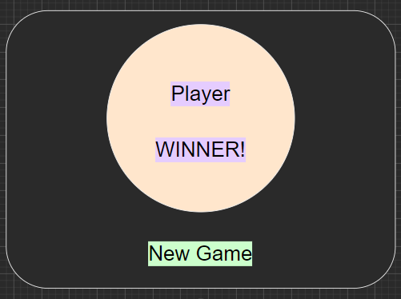

**Mind map/flow**

**Game components**

cards as follows:

* 0-9 red
* 0-9 blue
* 0-9 green
* 0-9 yellow
* 4 Skip in each colour
* 4 Reverse in each colour
* 2 attack cards in each colour
* 2 colour change cards in each colour
* 2 King, Queen, Knight, Ace

Action cards

* Attack Cards: This card launches an attack where the next unfortunate player has to draw extra cards from the deck
* Colour Change: This card allows you to select a desired colour to be played
* Reverse: This card reverses the flow of the turn
* Skip Cards: This card will cause the next player to skip their turn

Special cards

When a special card is played, the next player must draw one or more cards, or play another special card. King, Queen, Knight and Ace: These cards are special cards with special abilities. Watch out!

* King: Wild card that lets you skip your turn so you can avoid the “attacks”
* Queen: +5 attack card
* Knight: Makes everyone draw 2
* Ace: Neutralises the attacks
* Queen of Ace: removes all green cards from player’s hands (BONUS)

**Tech stack used**

1. HTML5
2. CSS
3. JavaScript (with jQuery)
4. Background sounds (BONUS)